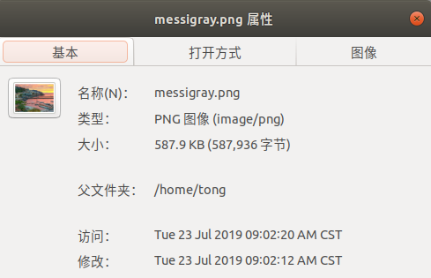
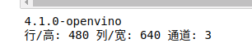

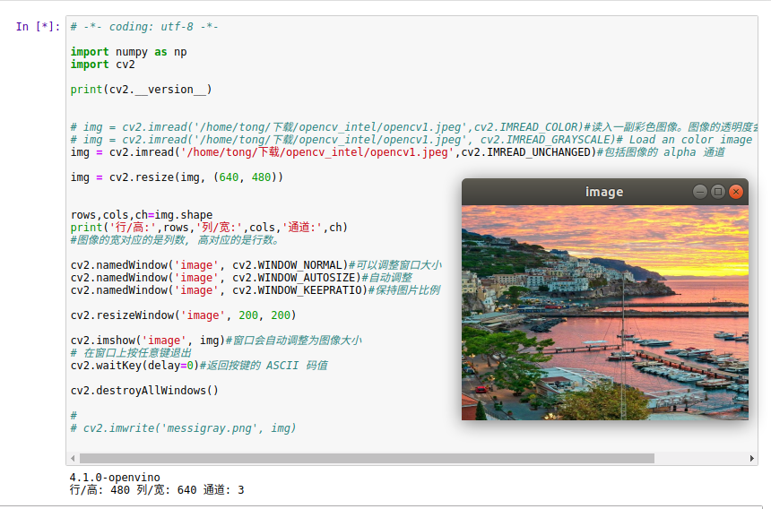

# -*- coding: utf-8 -*-

import numpy as np
import cv2

print(cv2.__version__)

# img = cv2.imread('/home/tong/下载/opencv_intel/opencv1.jpeg',cv2.IMREAD_COLOR)#读入一副彩色图像。图像的透明度会被忽略 默认参数。
# img = cv2.imread('/home/tong/下载/opencv_intel/opencv1.jpeg', cv2.IMREAD_GRAYSCALE)# Load an color image in grayscale 灰度
img = cv2.imread('/home/tong/下载/opencv_intel/opencv1.jpeg',cv2.IMREAD_UNCHANGED)#包括图像的 alpha 通道

img = cv2.resize(img, (640, 480))

rows,cols,ch=img.shape
print('行/高:',rows,'列/宽:',cols,'通道:',ch)
#图像的宽对应的是列数, 高对应的是行数。

cv2.namedWindow('image', cv2.WINDOW_NORMAL)#可以调整窗口大小
cv2.namedWindow('image', cv2.WINDOW_AUTOSIZE)#自动调整
cv2.namedWindow('image', cv2.WINDOW_KEEPRATIO)#保持图片比例

cv2.resizeWindow('image', 200, 200)

cv2.imshow('image', img)#窗口会自动调整为图像大小
# 在窗口上按任意键退出
cv2.waitKey(delay=0)#返回按键的 ASCII 码值

cv2.destroyAllWindows()

#
# cv2.imwrite('messigray.png', img)

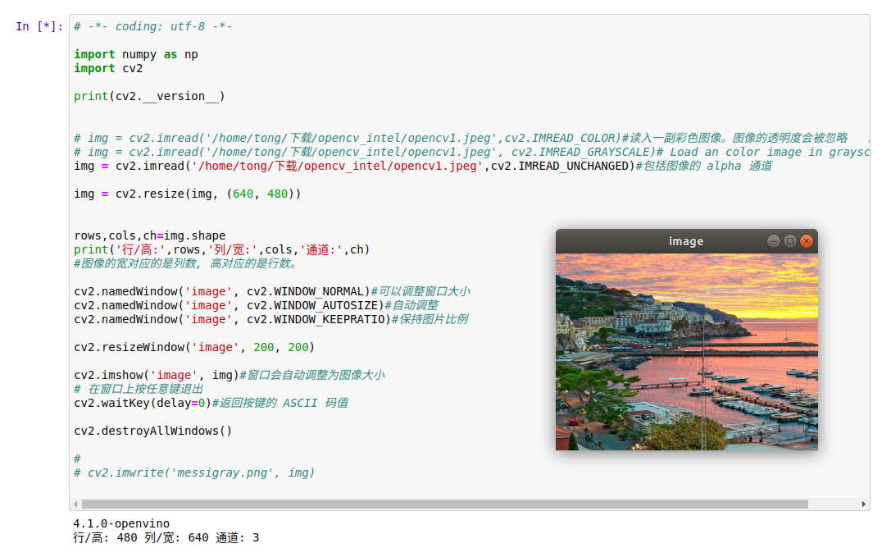
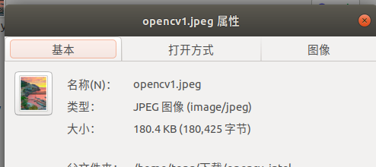

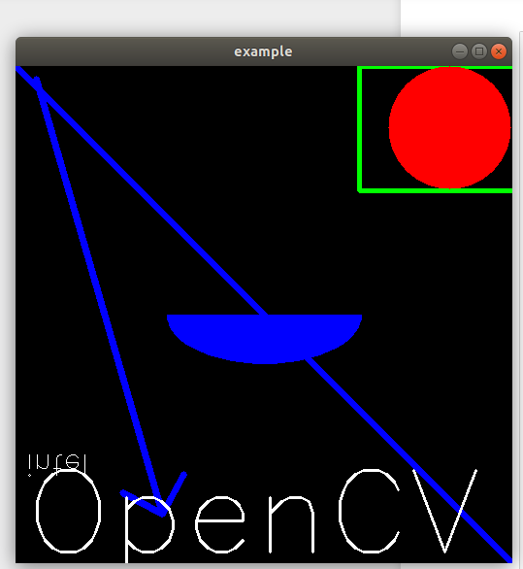

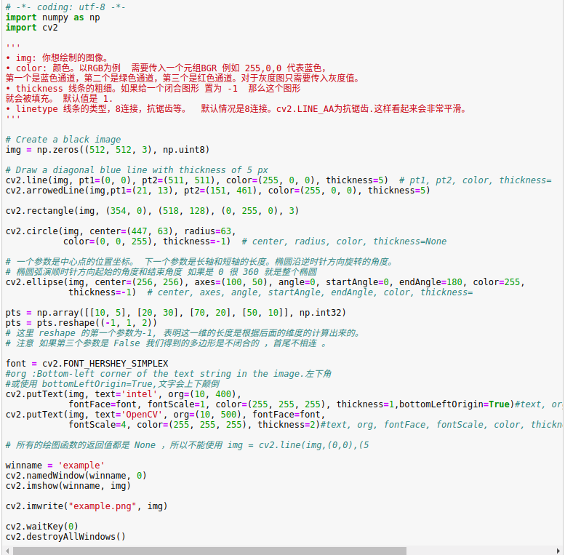

# -*- coding: utf-8 -*-
import numpy as np
import cv2

'''
• img: 你想绘制的图像。
• color: 颜色。以RGB为例 需要传入一个元组BGR 例如 255,0,0 代表蓝色，
第一个是蓝色通道，第二个是绿色通道，第三个是红色通道。对于灰度图只需要传入灰度值。
• thickness 线条的粗细。如果给一个闭合图形 置为 -1 那么这个图形
就会被填充。 默认值是 1.
• linetype 线条的类型，8连接，抗锯齿等。 默认情况是8连接。cv2.LINE_AA为抗锯齿.这样看起来会非常平滑。
'''

# Create a black image
img = np.zeros((512, 512, 3), np.uint8)

# Draw a diagonal blue line with thickness of 5 px
cv2.line(img, pt1=(0, 0), pt2=(511, 511), color=(255, 0, 0), thickness=5) # pt1, pt2, color, thickness=
cv2.arrowedLine(img,pt1=(21, 13), pt2=(151, 461), color=(255, 0, 0), thickness=5)

cv2.rectangle(img, (354, 0), (518, 128), (0, 255, 0), 3)

cv2.circle(img, center=(447, 63), radius=63,
color=(0, 0, 255), thickness=-1) # center, radius, color, thickness=None

# 一个参数是中心点的位置坐标。 下一个参数是长轴和短轴的长度。椭圆沿逆时针方向旋转的角度。
# 椭圆弧演顺时针方向起始的角度和结束角度 如果是 0 很 360 就是整个椭圆
cv2.ellipse(img, center=(256, 256), axes=(100, 50), angle=0, startAngle=0, endAngle=180, color=255,
thickness=-1) # center, axes, angle, startAngle, endAngle, color, thickness=

pts = np.array([[10, 5], [20, 30], [70, 20], [50, 10]], np.int32)
pts = pts.reshape((-1, 1, 2))
# 这里 reshape 的第一个参数为-1, 表明这一维的长度是根据后面的维度的计算出来的。
# 注意 如果第三个参数是 False 我们得到的多边形是不闭合的 ，首尾不相连 。

font = cv2.FONT_HERSHEY_SIMPLEX
#org :Bottom-left corner of the text string in the image.左下角
#或使用 bottomLeftOrigin=True,文字会上下颠倒
cv2.putText(img, text='intel', org=(10, 400),
fontFace=font, fontScale=1, color=(255, 255, 255), thickness=1,bottomLeftOrigin=True)#text, org, fontFace, fontScale, color, thickness=
cv2.putText(img, text='OpenCV', org=(10, 500), fontFace=font,
fontScale=4, color=(255, 255, 255), thickness=2)#text, org, fontFace, fontScale, color, thickness=

# 所有的绘图函数的返回值都是 None ，所以不能使用 img = cv2.line(img,(0,0),(5

winname = 'example'
cv2.namedWindow(winname, 0)
cv2.imshow(winname, img)

cv2.imwrite("example.png", img)

cv2.waitKey(0)
cv2.destroyAllWindows()

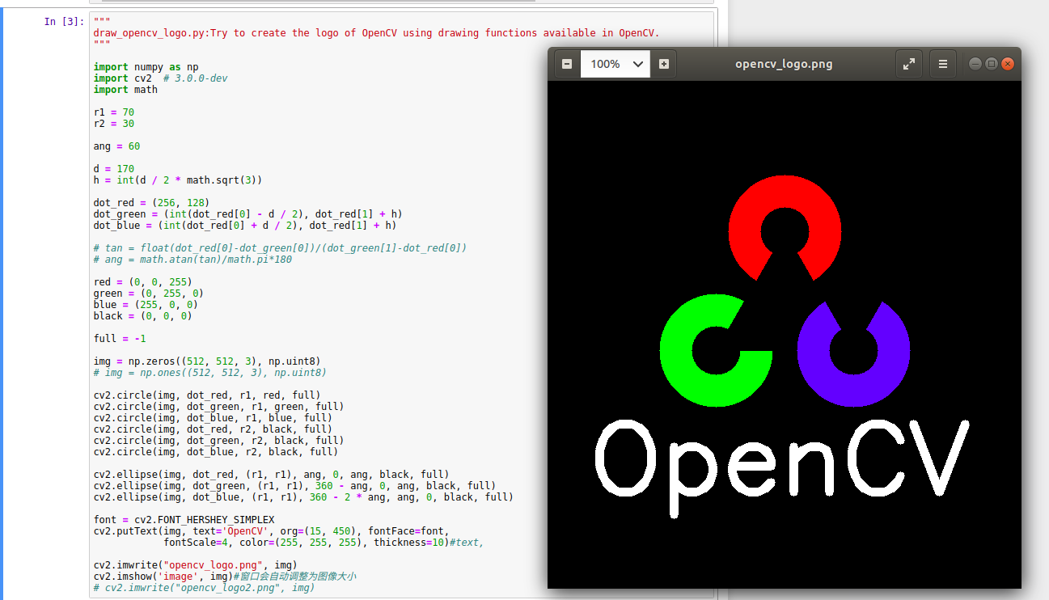

"""
draw_opencv_logo.py:Try to create the logo of OpenCV using drawing functions available in OpenCV.
"""

import numpy as np
import cv2 # 3.0.0-dev
import math

r1 = 70
r2 = 30

ang = 60

d = 170
h = int(d / 2 * math.sqrt(3))

dot_red = (256, 128)
dot_green = (int(dot_red[0] - d / 2), dot_red[1] + h)
dot_blue = (int(dot_red[0] + d / 2), dot_red[1] + h)

# tan = float(dot_red[0]-dot_green[0])/(dot_green[1]-dot_red[0])
# ang = math.atan(tan)/math.pi*180

red = (0, 0, 255)
green = (0, 255, 0)
blue = (255, 0, 0)
black = (0, 0, 0)

full = -1

img = np.zeros((512, 512, 3), np.uint8)
# img = np.ones((512, 512, 3), np.uint8)

cv2.circle(img, dot_red, r1, red, full)
cv2.circle(img, dot_green, r1, green, full)
cv2.circle(img, dot_blue, r1, blue, full)
cv2.circle(img, dot_red, r2, black, full)
cv2.circle(img, dot_green, r2, black, full)
cv2.circle(img, dot_blue, r2, black, full)

cv2.ellipse(img, dot_red, (r1, r1), ang, 0, ang, black, full)
cv2.ellipse(img, dot_green, (r1, r1), 360 - ang, 0, ang, black, full)
cv2.ellipse(img, dot_blue, (r1, r1), 360 - 2 * ang, ang, 0, black, full)

font = cv2.FONT_HERSHEY_SIMPLEX
cv2.putText(img, text='OpenCV', org=(15, 450), fontFace=font,
fontScale=4, color=(255, 255, 255), thickness=10)#text,

cv2.imwrite("opencv_logo.png", img)
cv2.imshow('image', img)#窗口会自动调整为图像大小
# cv2.imwrite("opencv_logo2.png", img)

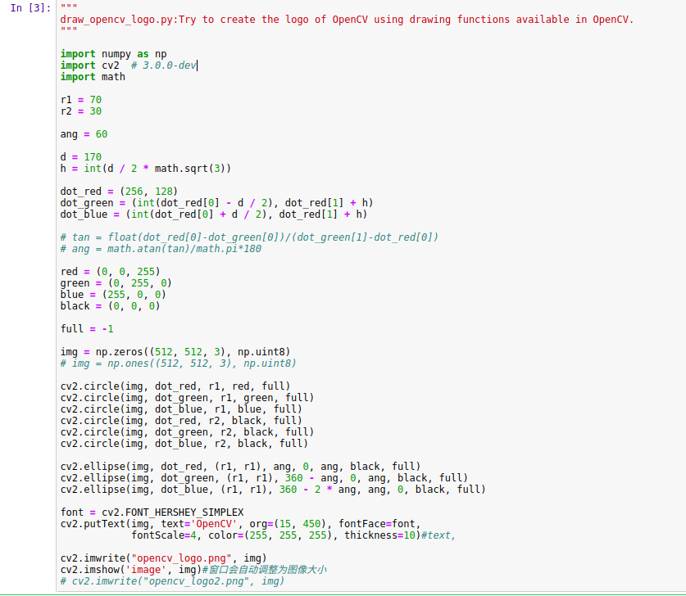

"""
画圆圈.py:随机覆盖，不同颜色，
"""
from time import sleep
import cv2
import numpy as np

def click_event(event, x, y, flags, param):
'''
用左键点击屏幕，打印坐标
:param event:
:param x:
:param y:
:param flags:
:param param:
:return:
'''
if event == cv2.EVENT_LBUTTONDOWN:
print(x, y, flags, param)

cv2.namedWindow('Canvas', cv2.WINDOW_GUI_EXPANDED)
cv2.setMouseCallback("Canvas", click_event)

canvas = np.zeros((300, 300, 3), dtype="uint8")
while True:
try:
for i in range(0, 25):
radius = np.random.randint(5, high=200)
color = np.random.randint(0, high=256, size=(3,)).tolist()
pt = np.random.randint(0, high=300, size=(2,))
cv2.circle(canvas, tuple(pt), radius, color, -1)

cv2.imshow("Canvas", canvas)

key = cv2.waitKey(1000) # 等待1秒
if key == ord('q'):
break
else:
# sleep(1)
continue
except KeyboardInterrupt as e:
print('KeyboardInterrupt', e)
finally:
cv2.imwrite('random-circles2.jpg', canvas)

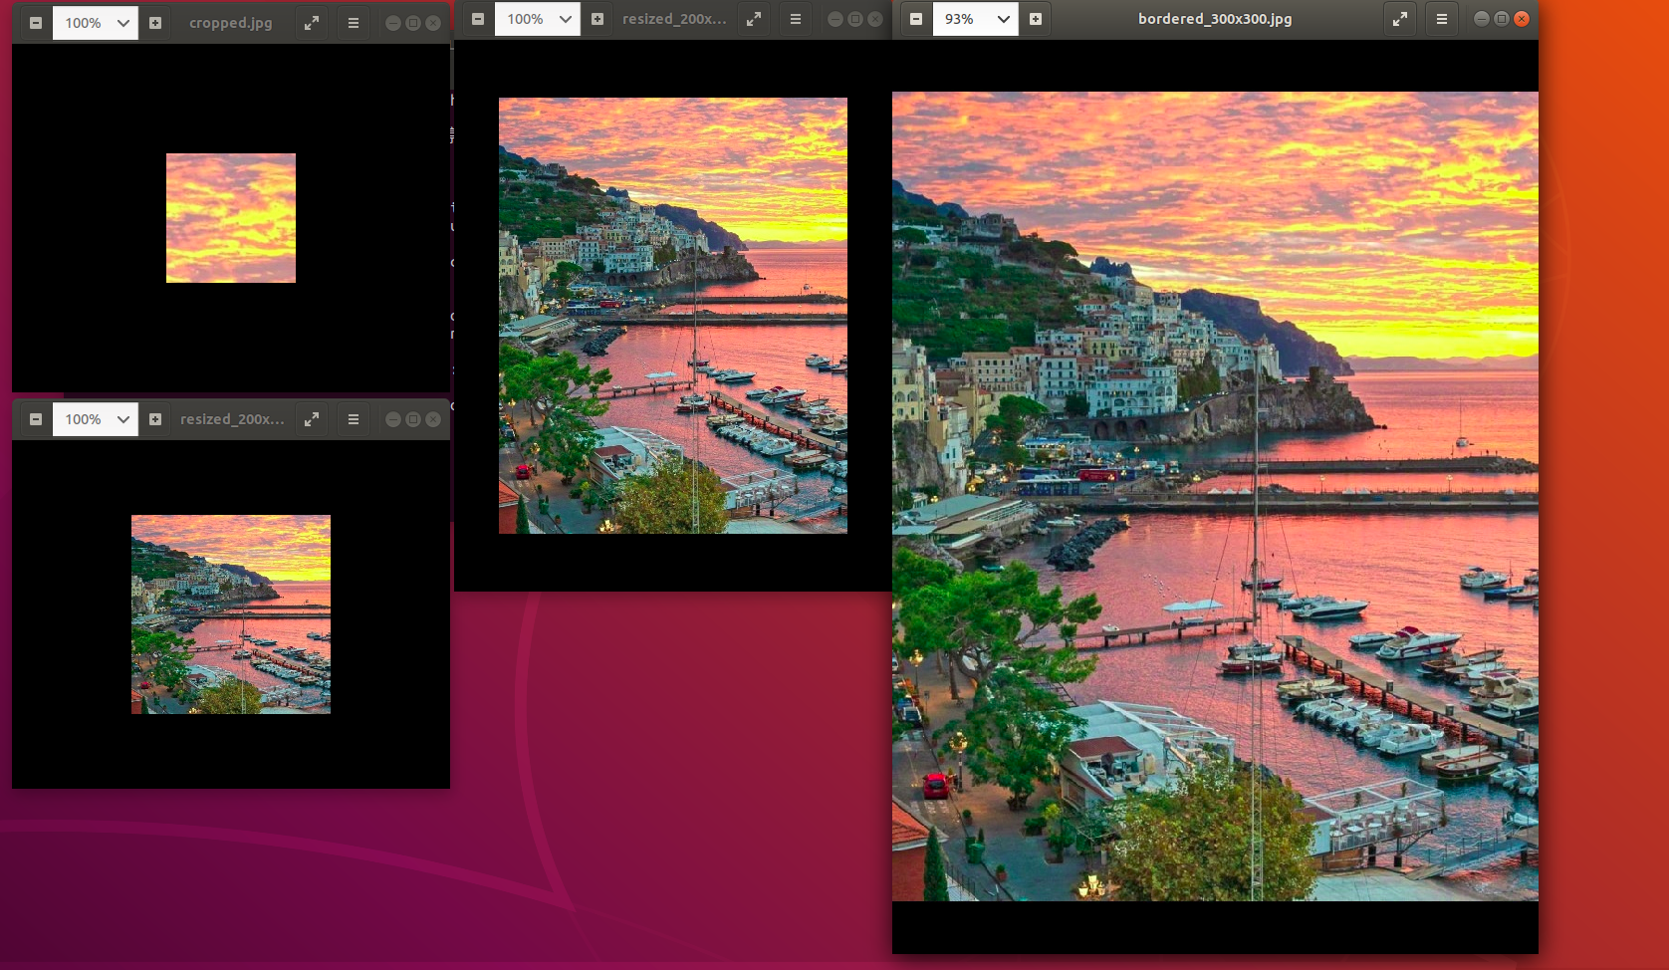
import cv2

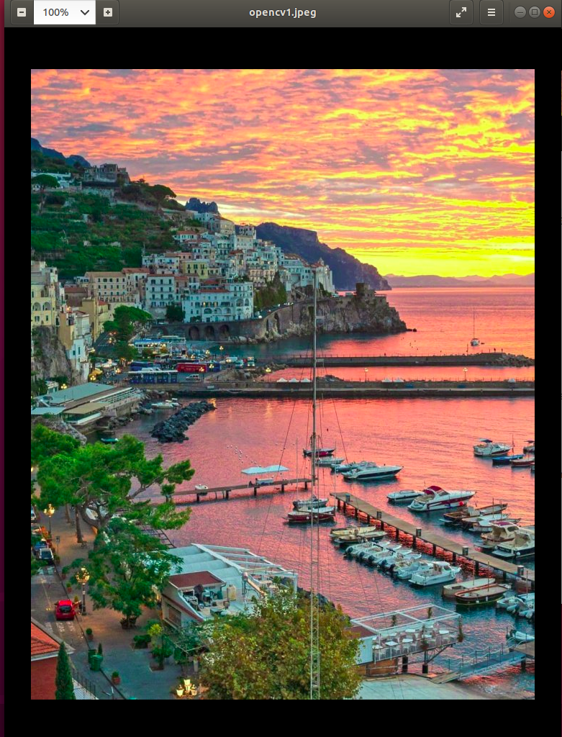
# 读取一张照片
img = cv2.imread('/home/tong/下载/opencv_intel/opencv1.jpeg')

# 缩放成200x200的方形图像
img_200x200 = cv2.resize(img, (200, 200))

# 不直接指定缩放后大小，通过fx和fy指定缩放比例，0.5则长宽都为原来一半
# 等效于img_200x300 = cv2.resize(img, (300, 200))，注意指定大小的格式是(宽度,高度)
# 插值方法默认是cv2.INTER_LINEAR，这里指定为最近邻插值
img_200x300 = cv2.resize(img, (0, 0), fx=0.5, fy=0.5,
interpolation=cv2.INTER_NEAREST)

# 在上张图片的基础上，上下各贴50像素的黑边，生成300x300的图像
img_300x300 = cv2.copyMakeBorder(img, 50, 50, 0, 0,
cv2.BORDER_CONSTANT,
value=(0, 0, 0))

# 对照片中部分进行剪裁
patch_tree = img[20:150, -180:-50]

cv2.imwrite('cropped.jpg', patch_tree)
cv2.imwrite('resized_200x200.jpg', img_200x200)
cv2.imwrite('resized_200x300.jpg', img_200x300)
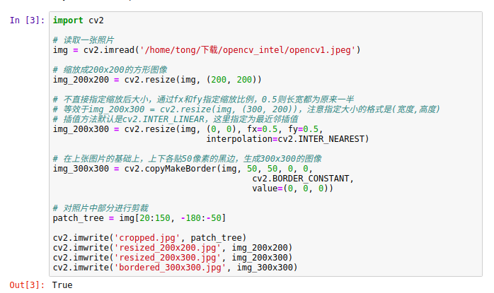
cv2.imwrite('bordered_300x300.jpg', img_300x300)

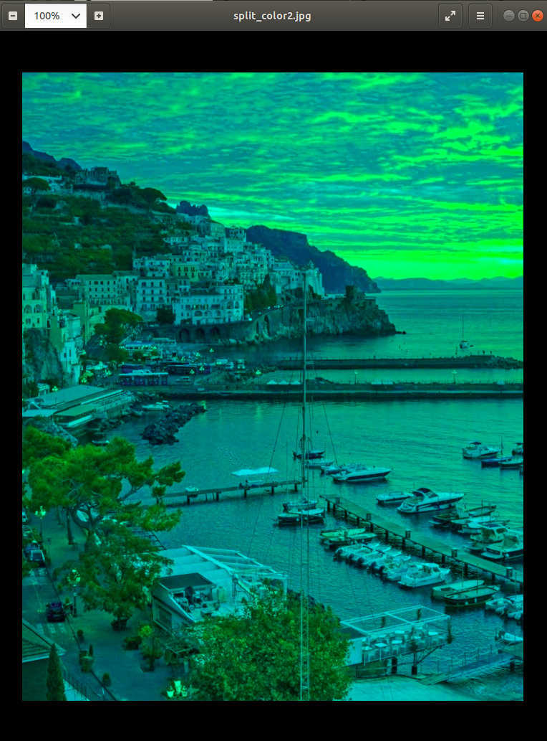

# -*- coding: utf-8 -*-
import cv2
import numpy as np
#拆分及合并图像通道

img = cv2.imread('/home/tong/下载/opencv_intel/opencv1.jpeg')

#
b,g,r=cv2.split(img)#比较耗时的操作，请使用numpy 索引
img=cv2.merge((b,g,r))
#
b=img[:,:,0]

#使所有像素的红色通道值都为 0,你不必先拆分再赋值。
# 你可以 直接使用 Numpy 索引,这会更快。
img[:,:,2]=0

#保存到文件，看下效果
cv2.imwrite(filename='split_color2.jpg',img=img)

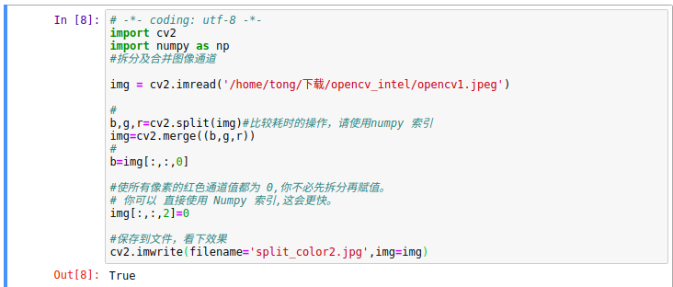
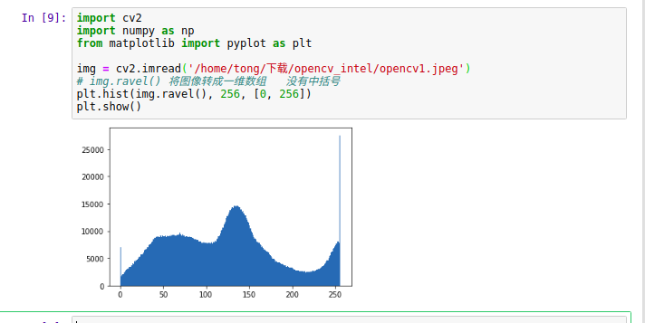
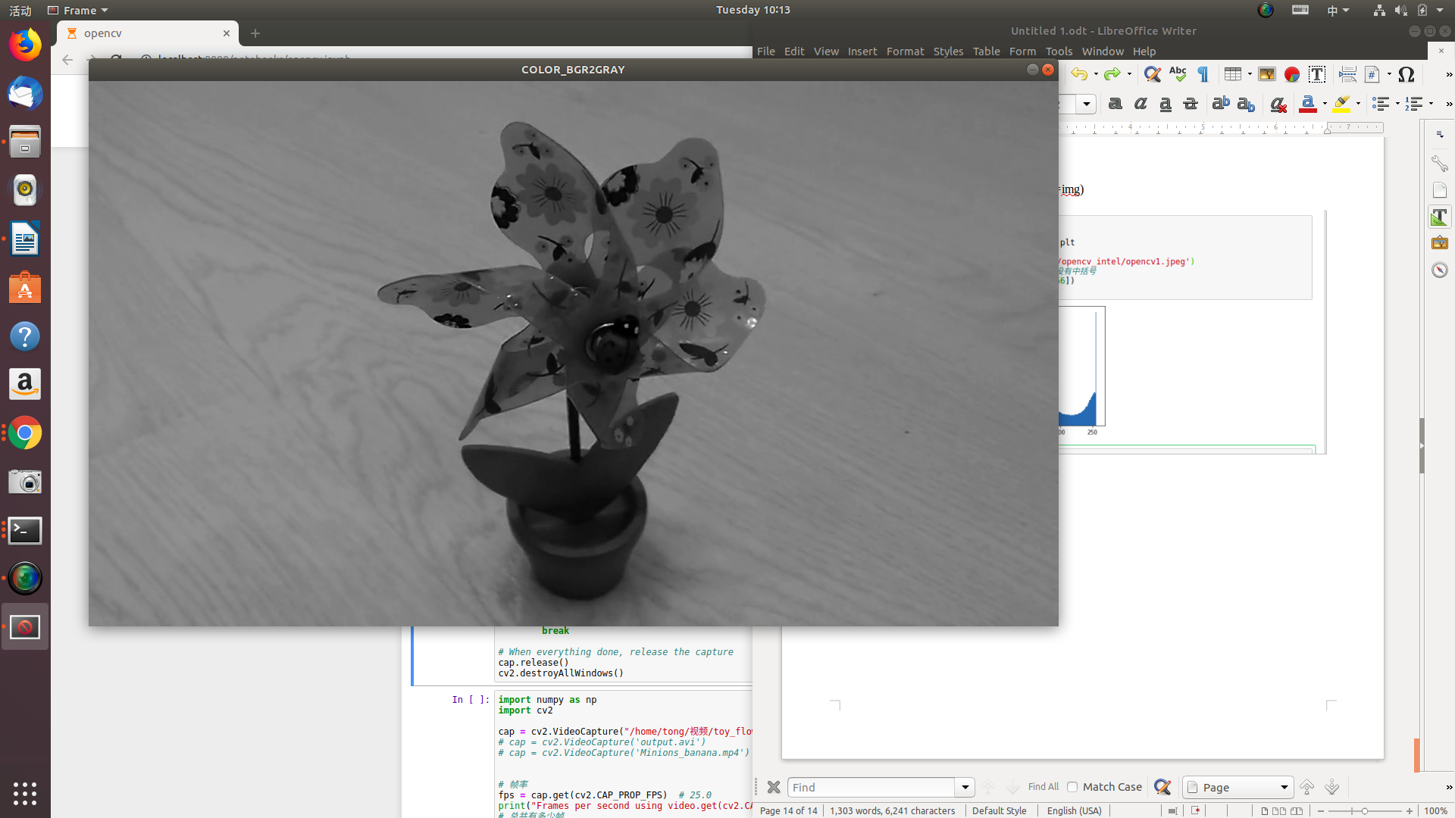
import numpy as np
import cv2

# cap = cv2.VideoCapture(0) # 一般的laptop有内置摄像头。所以参数就是 0。你可以设置成1或者其他的来选择别的摄像头
cap = cv2.VideoCapture("/home/tong/视频/toy_flower.mp4")
frame_height = cap.get(cv2.CAP_PROP_FRAME_HEIGHT)#4 ，720
frame_width = cap.get(cv2.CAP_PROP_FRAME_WIDTH)#3，1280
frame_height=int(480/frame_width*frame_height)#270
ret = cap.set(cv2.CAP_PROP_FRAME_HEIGHT, frame_height)#高
ret = cap.set(cv2.CAP_PROP_FRAME_WIDTH, 480)

# while (True):
while cap.isOpened(): # 检查是否成功初始化，否则就使用函数 cap.open()
# Capture frame-by-frame
ret, frame = cap.read() # ret 返回一个布尔值 True/False
# print('frame shape:',frame.shape)#(720, 1280, 3)

frame = cv2.flip(frame, flipCode=1) # 左右翻转,使用笔记本电脑摄像头才有用。
# flipCode：翻转方向：1：水平翻转；0：垂直翻转；-1：水平垂直翻转

# Our operations on the frame come here
gray = cv2.cvtColor(frame, cv2.COLOR_BGR2GRAY)

# Display the resulting frame
cv2.imshow('frame', gray)
cv2.setWindowTitle('frame', 'COLOR_BGR2GRAY')

key = cv2.waitKey(delay=10)
if key == ord("q"):
break

# When everything done, release the capture
cap.release()
cv2.destroyAllWindows()


